Product Listing and single product view.

A Customer Login and Registration page.

Cart and Watchlist.

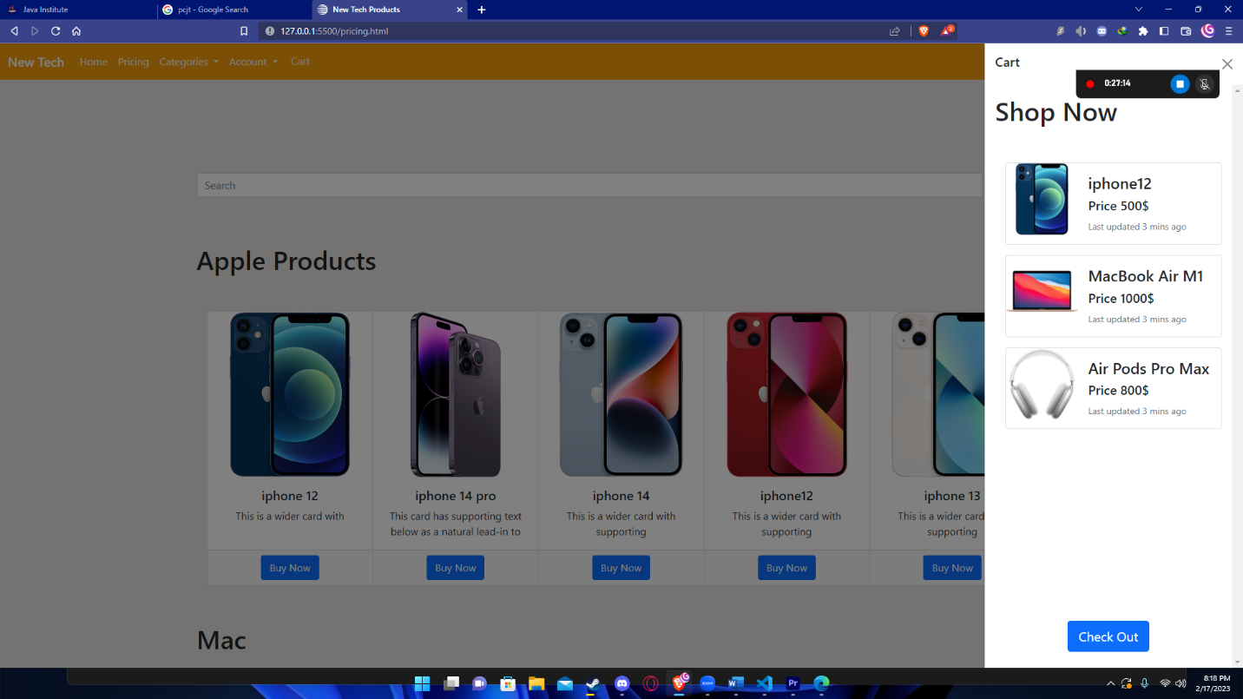

Admin Sign In

Manage Products and Manage Users Product adding and updating.

Product listing and single product view.

